|  |  |
| --- | --- |
| **Brick Dispenser** | |
|  | **1** |

|  |  |  |  |  |  |  |
| --- | --- | --- | --- | --- | --- | --- |
| **PARTS NEEDED** | Base Plate  http://images.studica.com/images/product/fischertechnik/86grundplatte.jpgx1 | mySTEM Board  mySTEM™ Project Board for NI myDAQx1 | NI myDAQ  NI myDAQ for Secondary Schoolsx1 | DC Motor  32293: S-MOTOR 6-9V x1 | Photo Transistor  36134: PHOTO-TRANSISTOR ASSEMBLEDx1 | Ball Lamp  37869: BALL LAMPx1 |
| Limit Switch  37783: MINI-SWITCHx2 | Building Block  32850: BUILDING BLOCK 15 X 15 x1 | Light Holder  38216: PLUG IN LIGHT HOLDER x1 | Gearbox  31078: Motor Reducing Gearbox Blackx1 | Rack & Pinion  37351: RACK & PINION 60  X1 | Bore Block  32064: BUILDING BLOCK WITH BORE x1 |
| Block 15  32881: BUILDING BLOCK 15x5 | Girder 15-2pins  36298: ANGLE GIRDER 15 WITH 2 PINSx5 | Statics Block  35076: STATICS BUILDING BLOCK x3 | Spring Ring Clip  37679: CLIP 5 WITH SPRING RING x4 | Angle Girder 60  36921: ANGLE GIRDER 60 BLACKx6 | Angle Girder 15  36950: ANGLE GIRDER 15 WITH 2 PINS x2 |
| Angle Block  38423: ANGLE BLOCK 10 X 15 X 15 x10 | Girder 60  36297: ANGLE GIRDER 60 x2 | Block 30  32880: BUILDING BLOCK 30 WITH BORE x14 | Building Plate  38428: BUILDING PLATE 15X30X5 WITH 3 GROOVES x5 | Rivet 4MM  36323: SINGLE RIVET 4 MM RED x1 | Plate 30 X 90  32859: BOTTOM PLATE 30 X 90 RED  x1 |
| Reed holder  35969: REED CONTACT AND CABLE CLAMP x2 | Reed Switch  36120: REED CONTACTx1 | Angle Girder 120  36293: ANGLE GIRDER 120 BLACK x2 | Building Block  37468: BUILDING BLOCK 7,5 x2 | Building Block  38240: BUILDING BLOCK V 15 CORNER x4 | Mounting Plate  38242: MOUNTING PLATE WITH PEG 15 X 45 REDx1 |
| Mounting Plate  38244: MOUNTING PLATE WITH PEG 15 X 75 RED x2 | Mounting Plate  38245: MOUNTING PLATE WITH PEG 15 X 90 RED x2 | Magnet Block  108278x1 | Angle Block 30  31011: ANGLE BLOCK ISOSCELES, 30 REDx3 | Angle Block 60  31010: ANGULAR BLOCK 60 x3 | Building Block 5  37237: BUILDING BLOCK 5 x5 |
| Axle 90  35066: WHEEL AXLE 90  x1 | Link 15  31060: LINK 15 x2 |  |  |  |  |

|  |
| --- |
| Assemble |

**Insert two Link 15 blocks from top on the both sides of the Block 15**

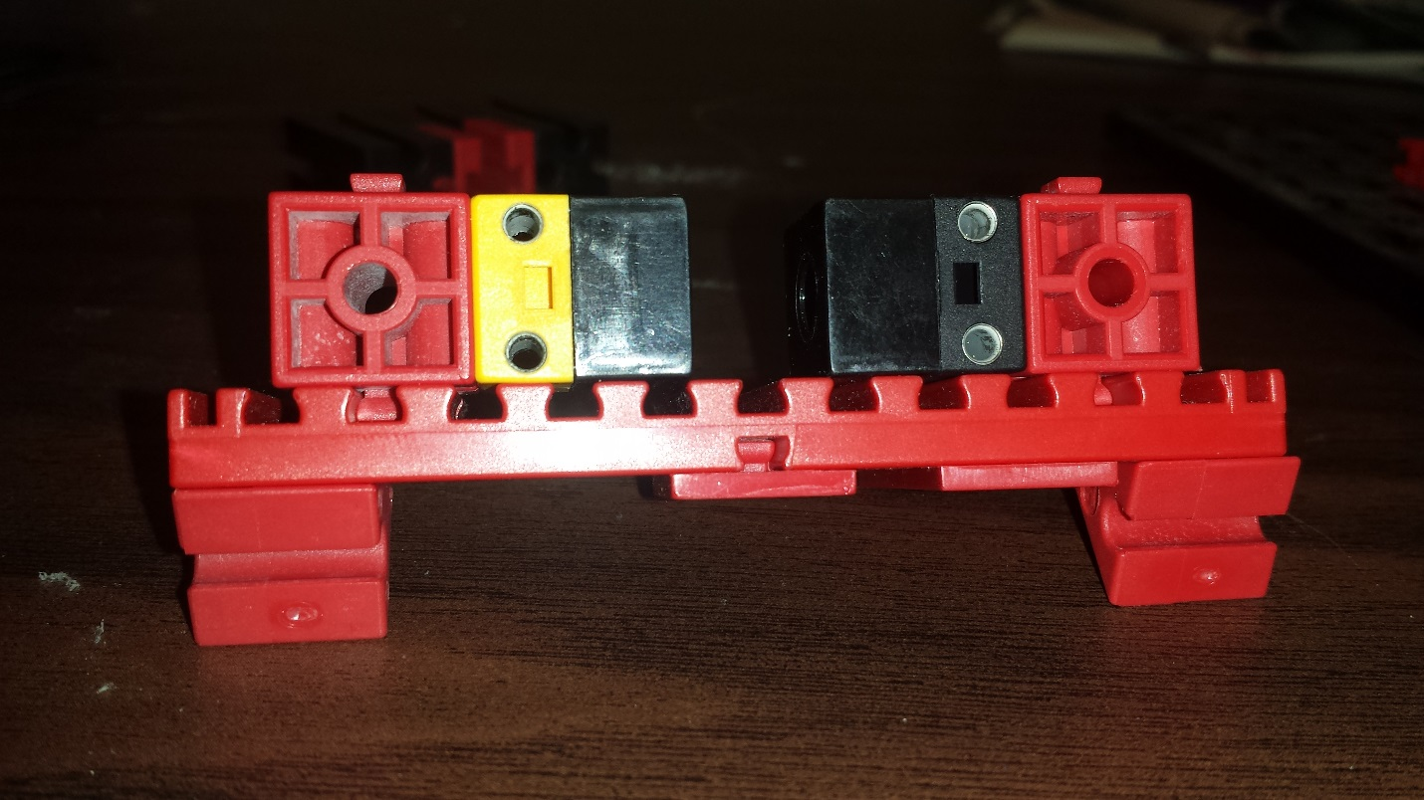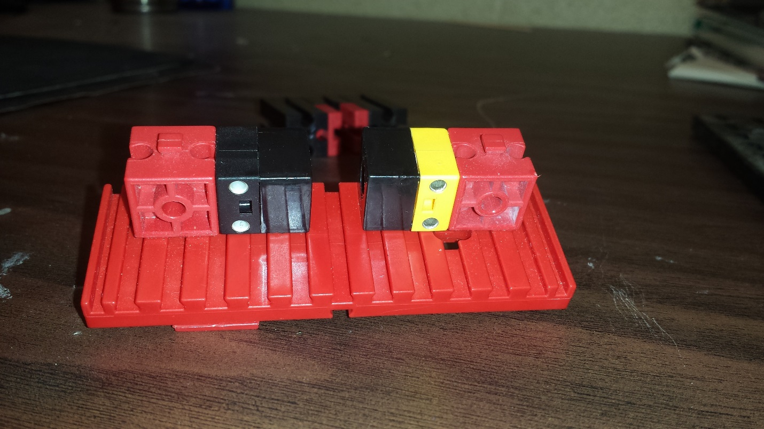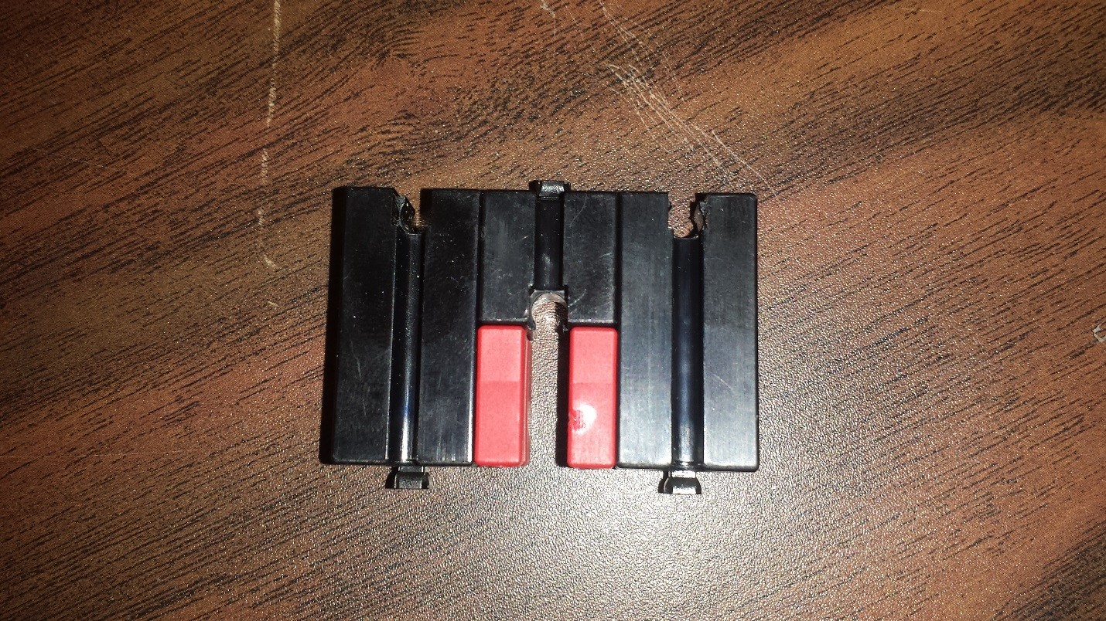

**Use two Block 30, one Block 15 and two Building Block 5 to create a coin dropping slot**

**Attach two Angle Block 60 on the two edges of Plate 30 X 90**

**On the second Bore Block, attach a Photo Transistor with a cap.**

**Attach a Ball Lamp and a Light Holder on a Bore Block (or Block 15)**

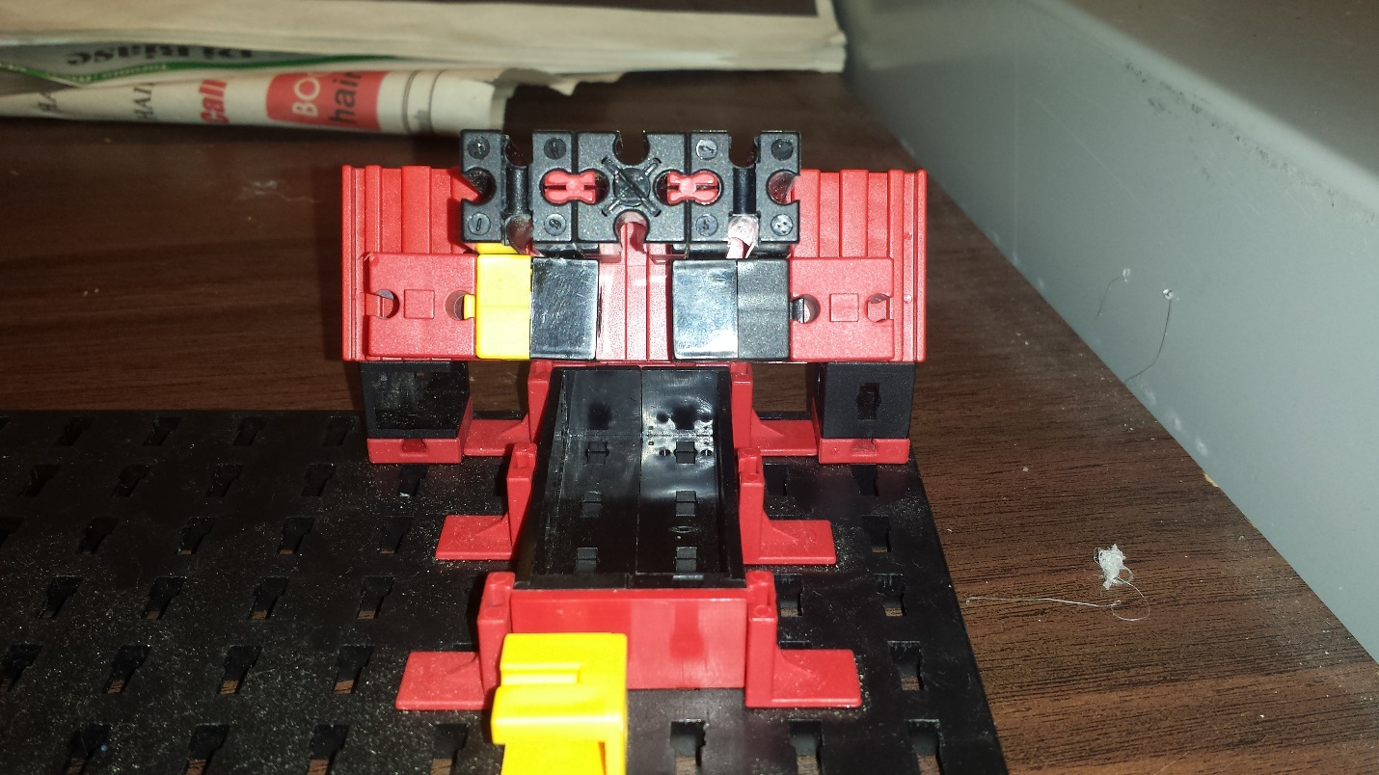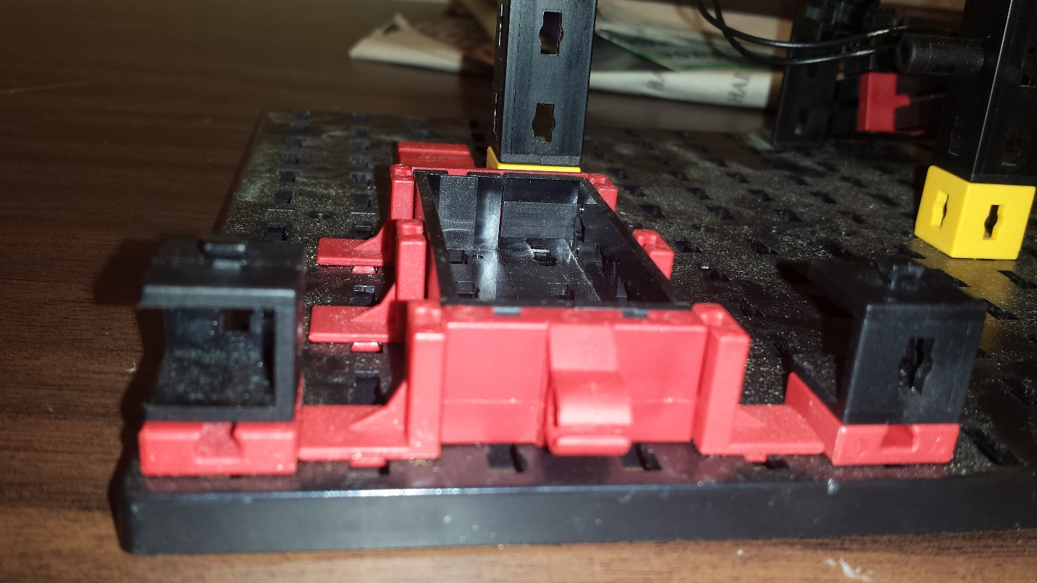

**Attach the Plate 30 X 90 made earlier on top of the two posts at Q1 and N1**

**Place the coin holder made earlier on top of the Photo Transistor and Ball Lamp**

**Put the tray in between the six Angle Blocks placed at 1M, 3M, 5M, 1P, 3P and 5P.**

**Use two Building Plates, two Angle Girder 60 and one Reed Holder to create a coin tray**

**Attach two Angle Girder 30 to two Building Block 5 at Q1 and N1 on the Base Plate**

**Place three Girder 150-2pins on N6, H6 and E6**

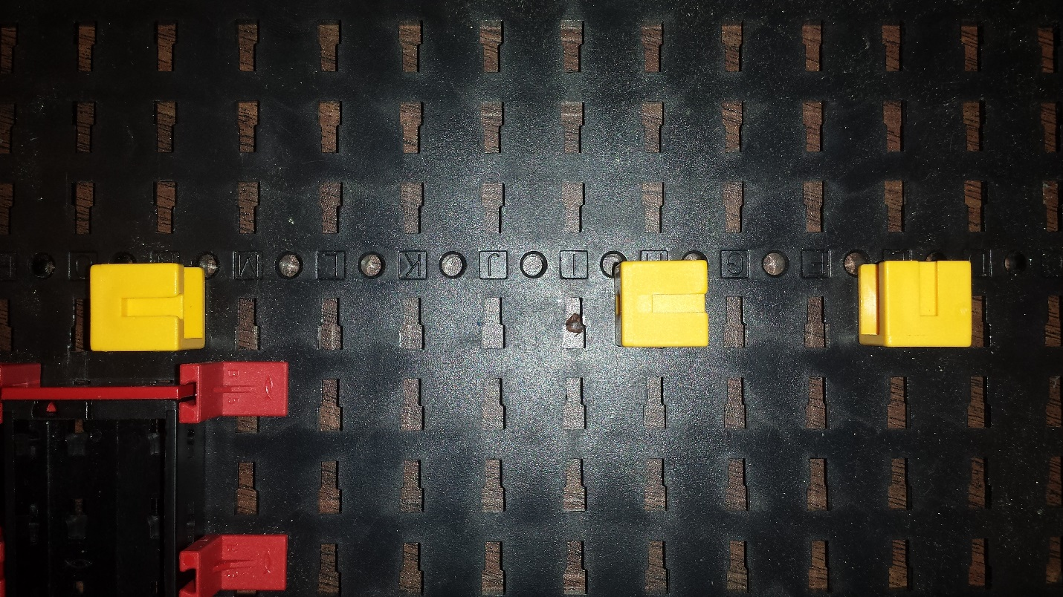

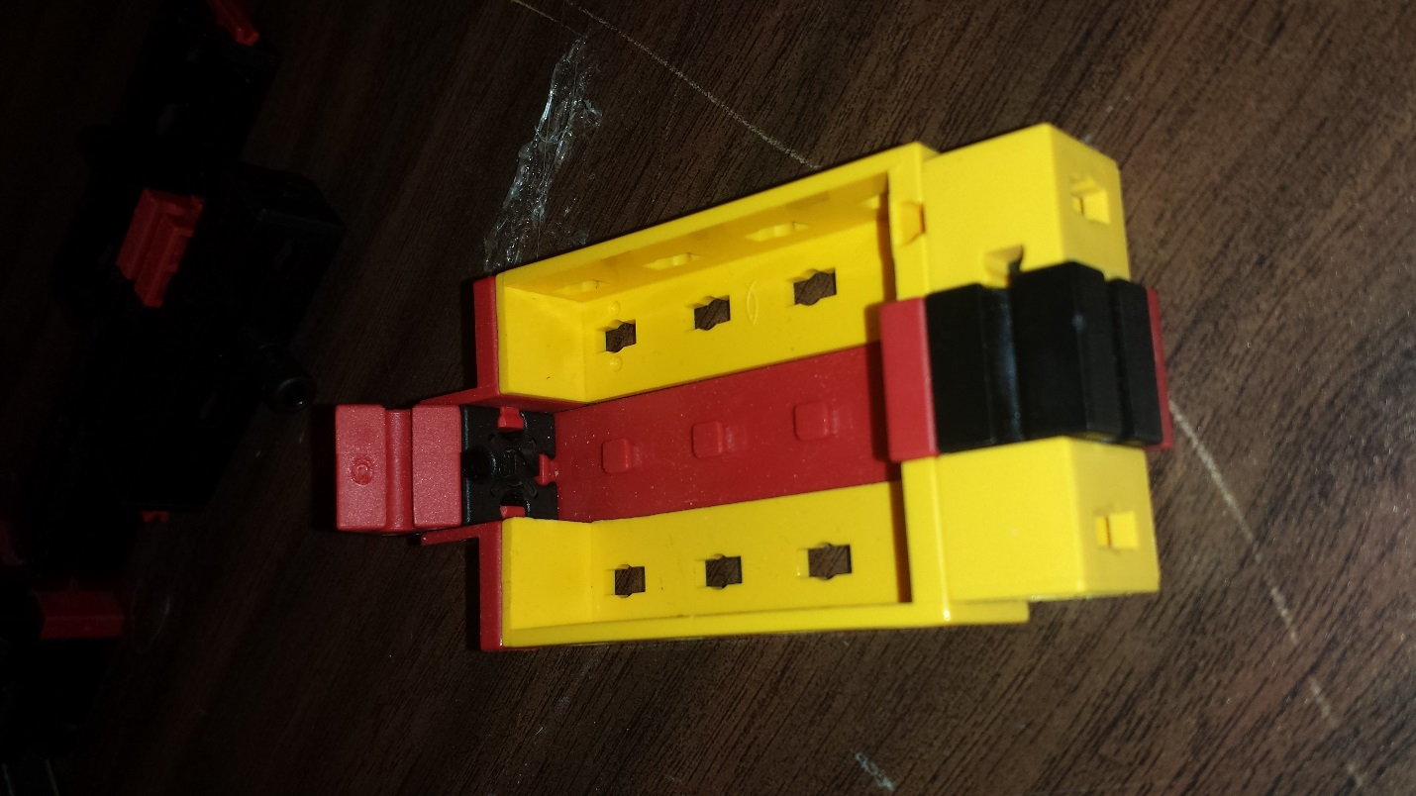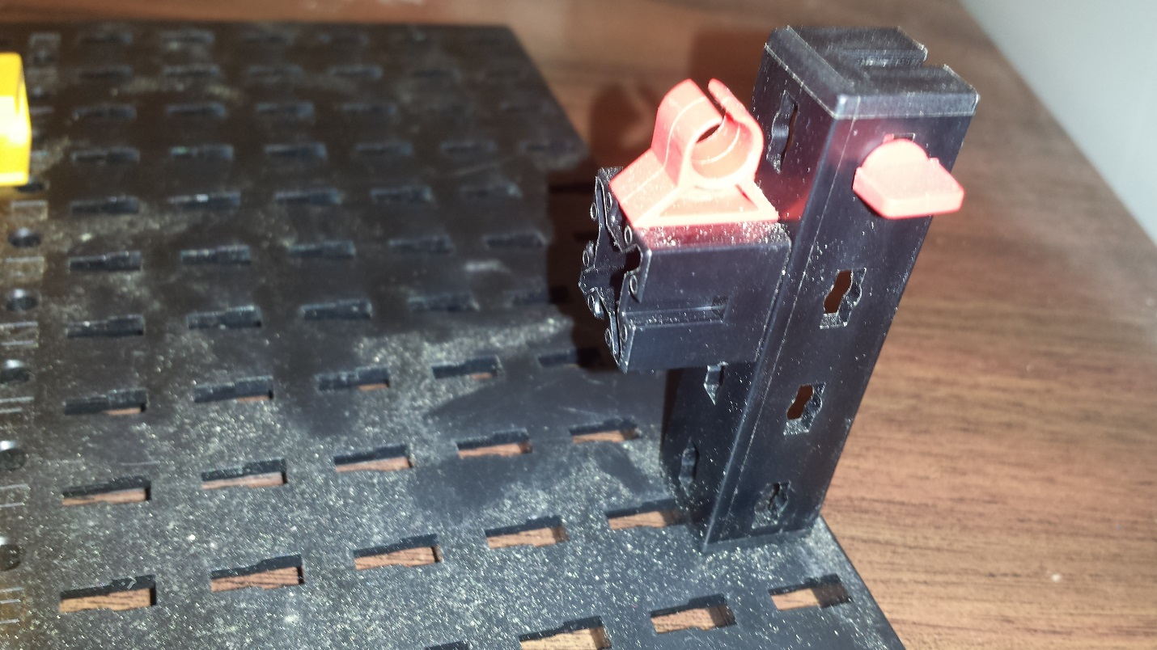

**Girder 60**

**Building Block**

**Block 15**

**Statics Block**

**Make the brick tray using the mentioned parts**

**Angle 60 Block**

**Mounting Plate**

**Attach 4MM Rivet on the Girder**

**Attach Building Block with Reed Switch Holder**

**Place Girder 60 on H12**

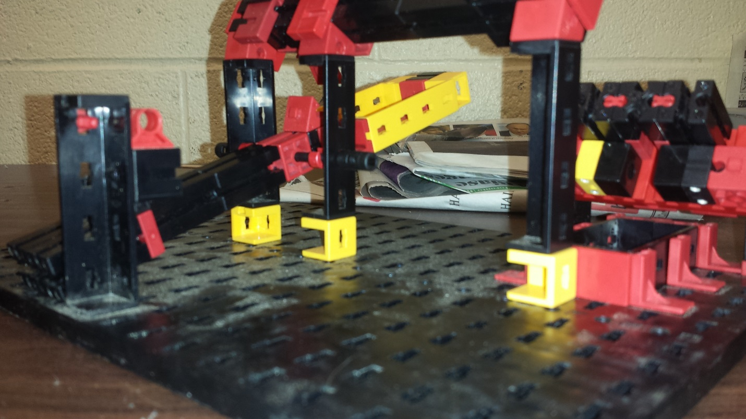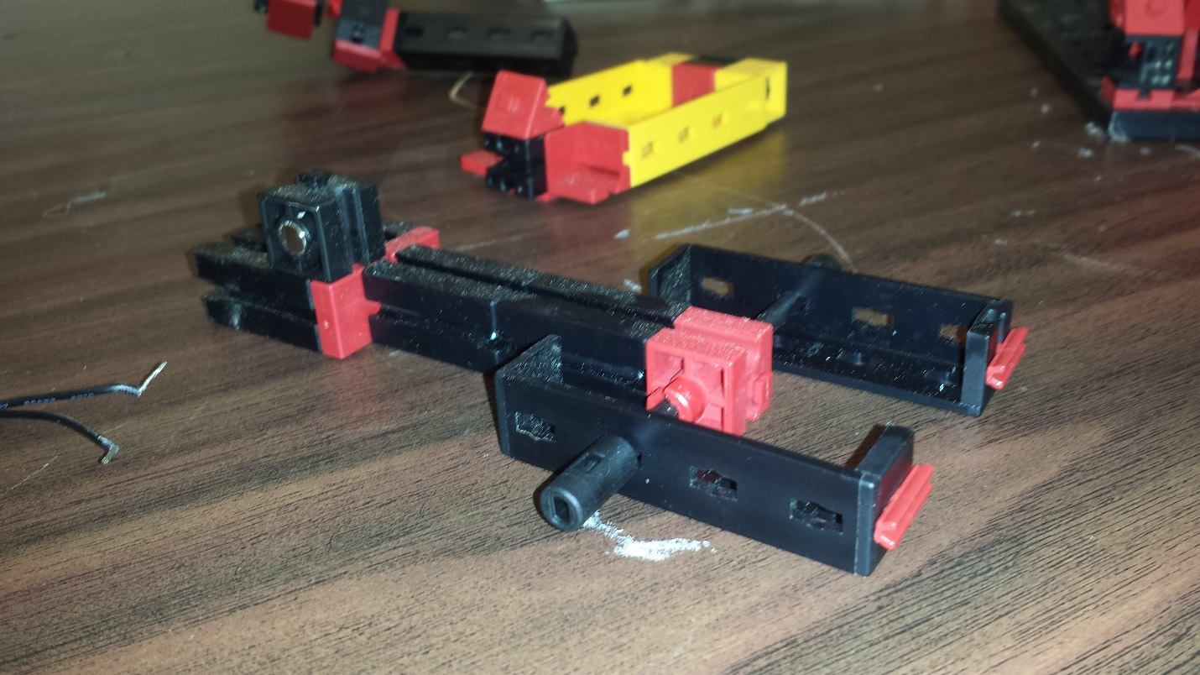

**Attach the brick tray and anchor point assembly between the two Girders**

**Attach the two Girders 60 to Girder 150-2pins.**

**Place Angle 30 on top on the three Girders 60.**

**Pass Axle 90 through the Bore Block and the two Girders. Put the Spring Ring Clip**

**Attach two Block 30 to a Bore Block. Attach this assembly to the Building Plate**

**Use two Block 30 and attach them to a Building Plate and a Magnet Block**

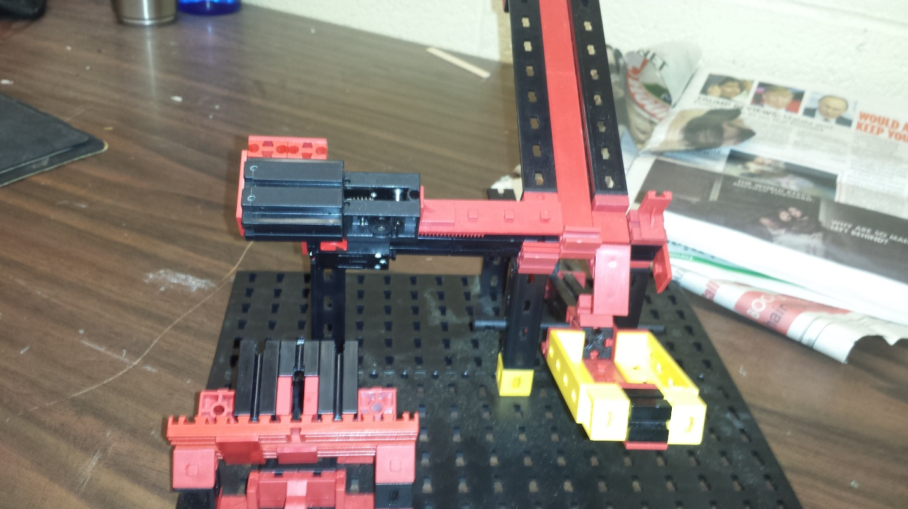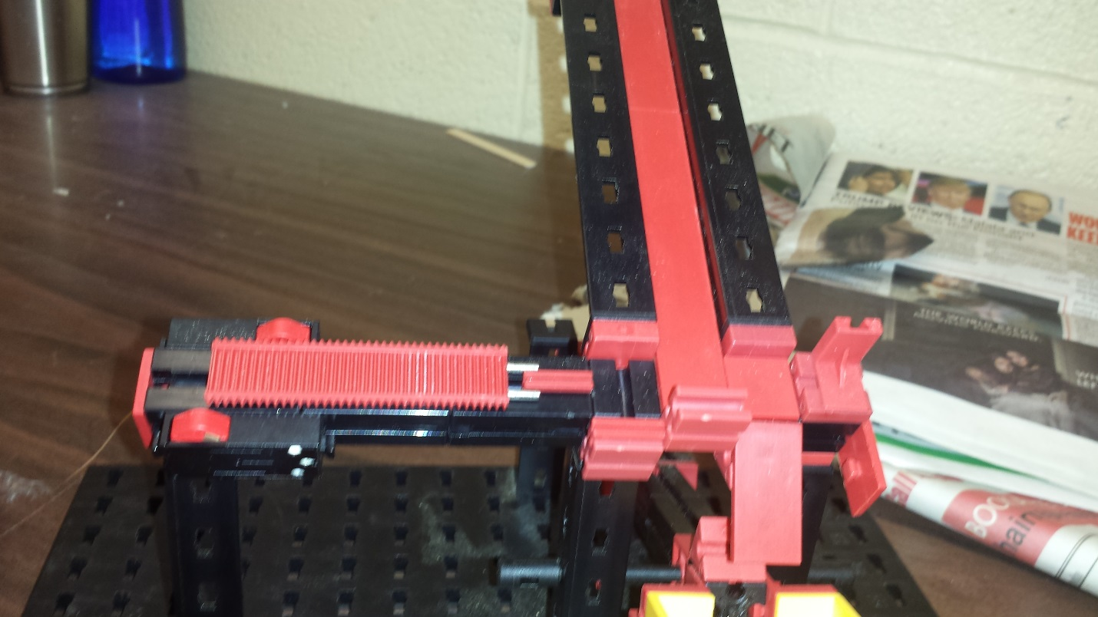

**After attaching a motor and a Gearbox to the Rack & Pinion, the finished model should like as shown.**

**Attach Building Block to the shaft as a stopper.**

**Attach Angle Block to Building Block 5**

**Attach two Girder 120 and a Mounting Plate**

**Add two Limit Switches**

**Attach Rack & Pinion**

**Attach five Block 30 together and place them on top of Angle Block 30**

|  |
| --- |
| Wiring |

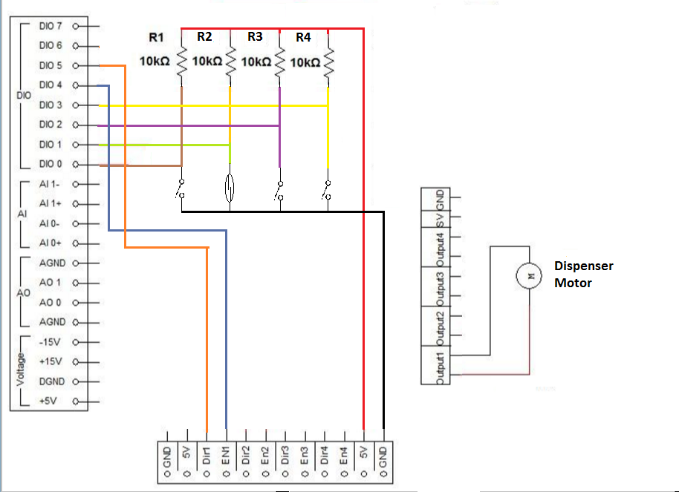

|  |
| --- |
| Program |

Before beginning, take a look at the flowchart below to understand the process and logic behind the Garage Door program.

G:\Downloads\Brick Dispenser - LabView (1).png

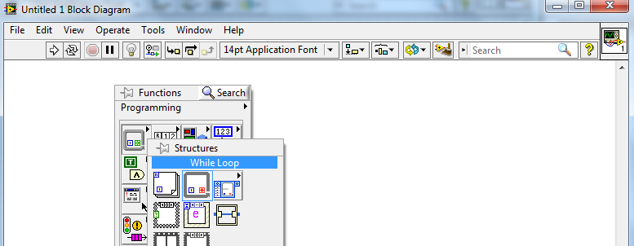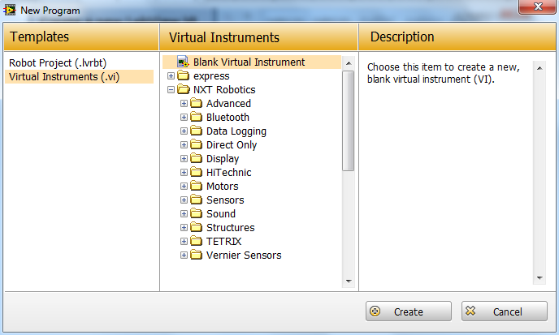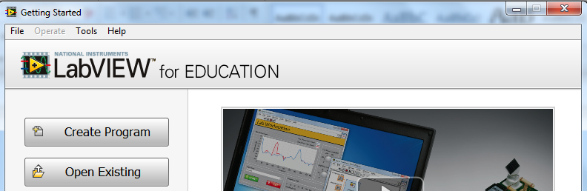

**The block diagram and front panel windows will appear. From the block diagram, right click to open Functions pallet. Go to Structures.**

**Select While Loop**

**Click Create**

**Choose Blank Virtual Instrument**

**Create a new LabView VI**

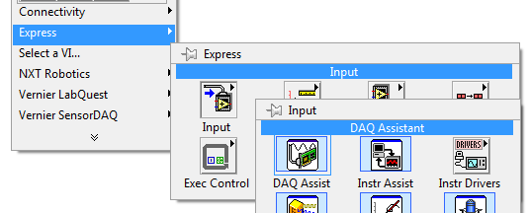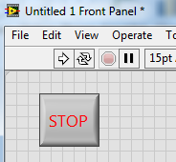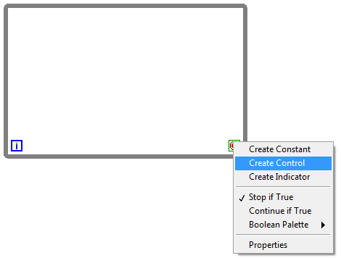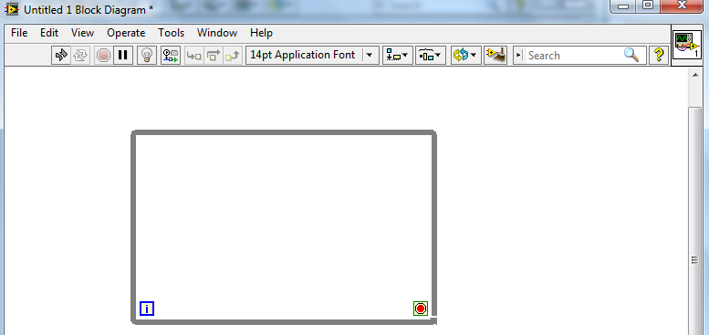

**Right click on the Loop Condition**

**Select Create Control**

**Stop Button will appear on the front panel window. Resize / Style it as you seem fit.**

**You can drag the borders to change the size as you need**

**Select DAQ Assistant**

**Choose Input**

**Open Functions pallet and go to Express**

**Drag mouse to create the while loop**

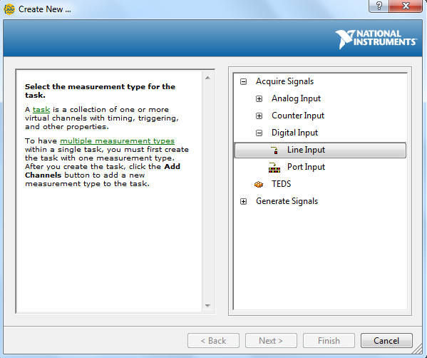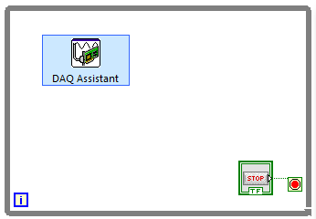

**At this point, make sure that the NI myDAQ device is connected to your computer before proceeding**

**Select Line Input**

**Choose Digital Input**

**A DAQ Assistant window will appear. Click on Acquire Signals**

**Place DAQ Assistant inside the while loop**

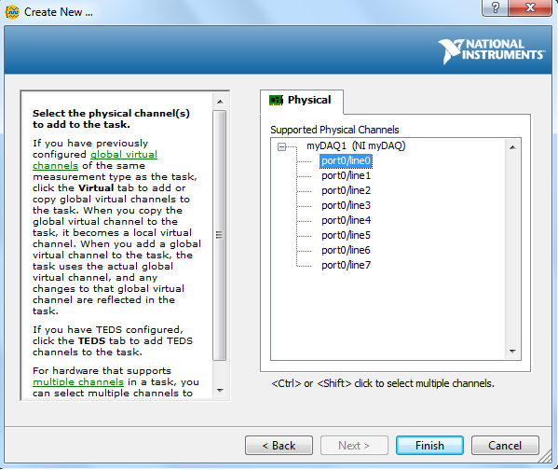

**Select Port 0**

**Your NI device will appear in the list**

**Click Finish**

**If your DAQ device doesn’t appear in the list, make sure to connect it to the computer via a USB. Then close the DAQ window and re-follow the steps to create the DAQ Assistant**

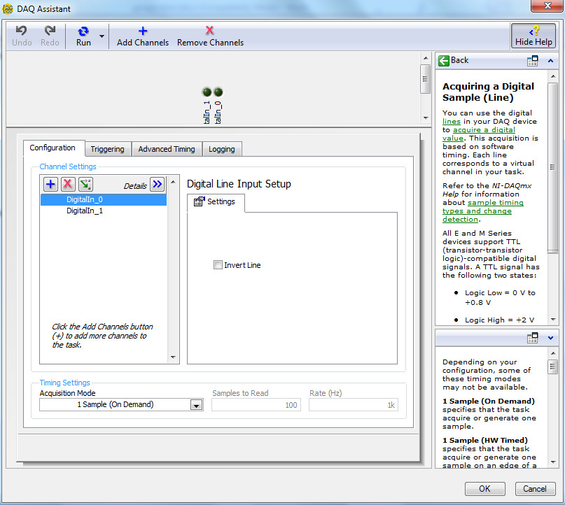

**It is possible to change the speed or rate at which the input is read. Leave it as it is for now.**

**Click OK to finalize the settings**

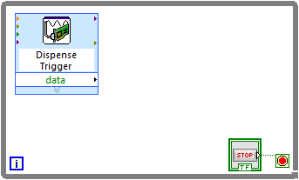

**Double-click to rename the DAQ Assistant to specify its purpose**

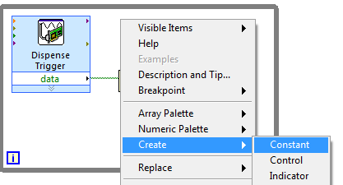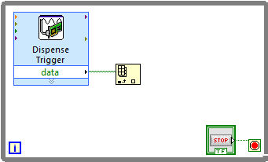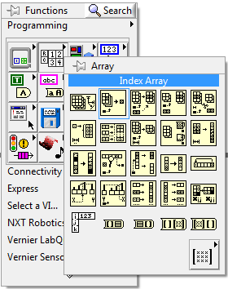

**Connect the data terminal of DAQ Assistant to array terminal of Index Array**

**Create an Index Array**

**Open Functions pallet and go to Array**

**Select Constant**

**Click on Create**

**Right click on the index terminal of Index Array**

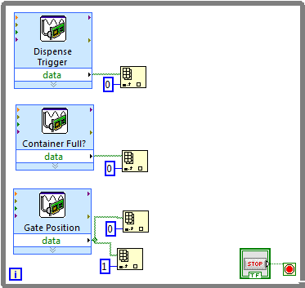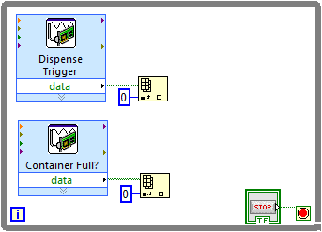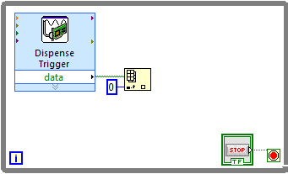

**Create another DAQ Assistant for the Gate Position using digital ports 2 and 3.**

**Connect it to two Index Arrays with constants 0 and 1**

**Create an Index Array for it and connect it in the same manner**

**Create a DAQ Assistant to check whether container is full using digital port 1**

**Give the constant a value of 0**

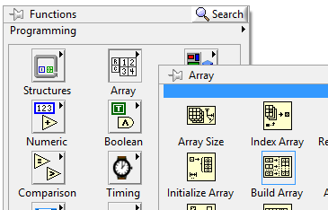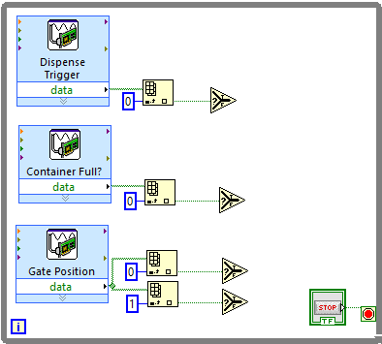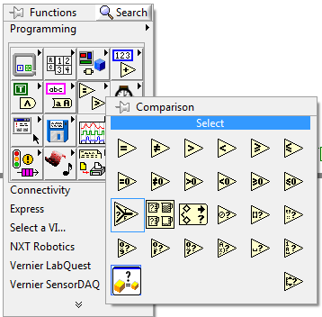

**Create a Build Array**

**From the Functions pallet, go to Array**

**Create four Select and connect each one to an Index Array as shown.**

**Create a Select Block**

**Go to Comparison from block diagram Functions pallet.**

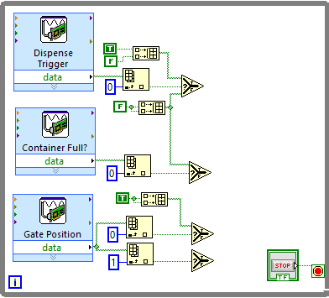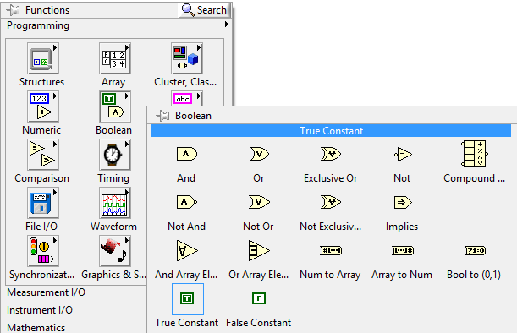

**Expand the size of Build Array from its bottom border to create another array element**

**Create a False Constant**

**Create a True Constant**

**Go to Boolean from the Functions pallet**

**Create four Build Array and six True/False Constants. Connect these Constants to the Build Arrays and connect the Build Arrays to the Selects as shown.**

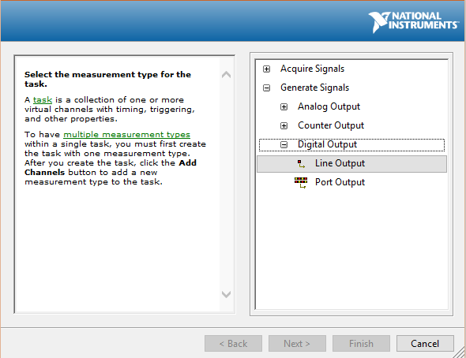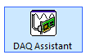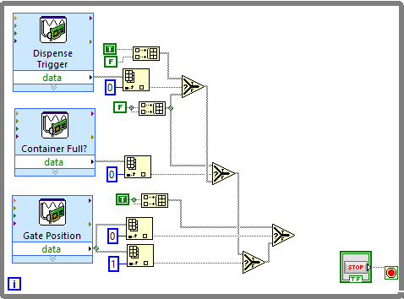

**From the DAQ Assistant window, choose Generate Signals**

**Choose Digital Output**

**Wire up the remaining terminals of the Selects as shown.**

**Create another DAQ Assistant from the Functions pallet.**

**Select Line Output**

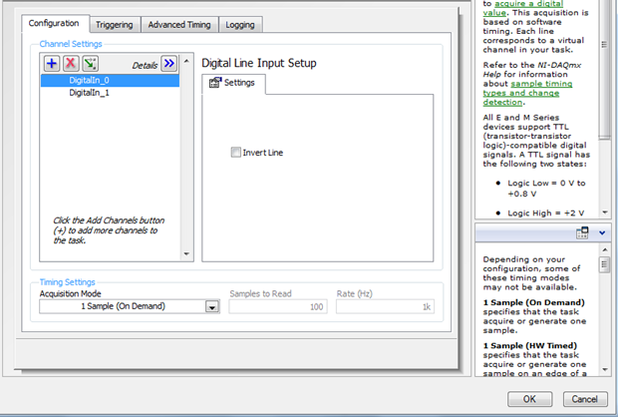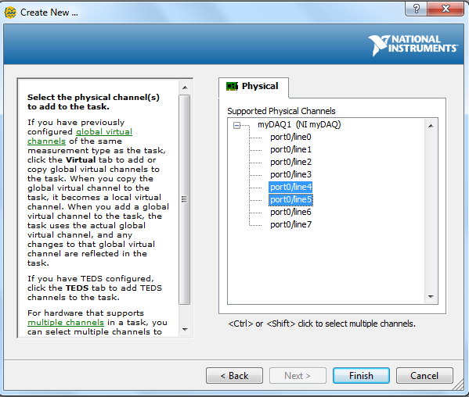

**Select Ports 4 and 5 using the Ctrl Key**

**Leave settings on next window as default and press OK**

**Click Finish**

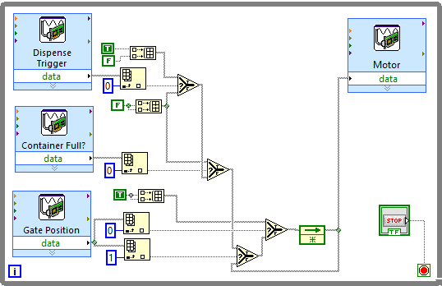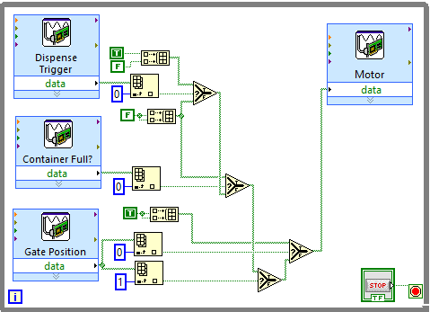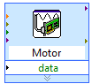

**Branch the wire going to the Motor and connect it to the f terminal of the Select**

**This will automatically create a Feedback Node**

**Connect the Select to the Motor DAQ Assistant**

**Rename the DAQ Assistant to specify its purpose**

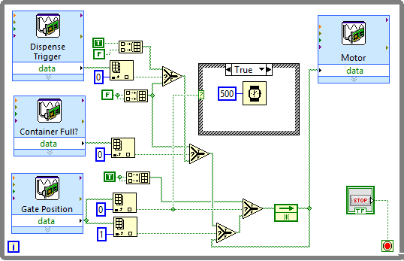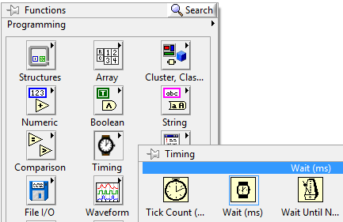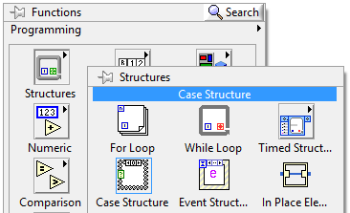

**Create a Wait (ms)**

**Open Timing from the Functions pallet.**

**Open Structures from the Functions pallet**

**Select Case Structure**

**Connect the Index Array wired to the Gate Position DAQ and with constant of 0 to the Case Structure by branching out its connection**

**Place the Wait (ms) inside the Case Structure and give it a constant value of 500**

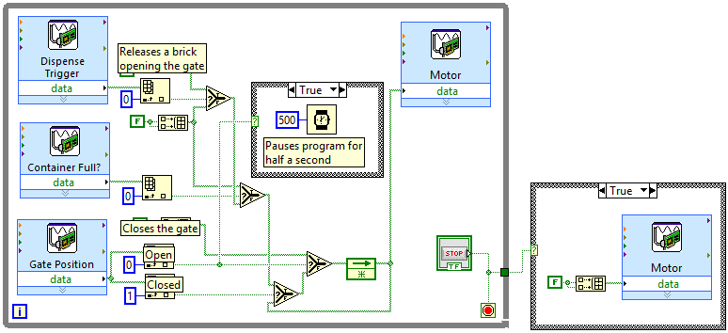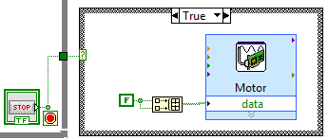

**Congratulations, your LabView VI is now complete. You may wish to add comments to specific portions of your program so that others can more easily understand it. You can do this by double-clicking at an empty space on the block diagram.**

**Connect the Case Structure to the Stop Button Control**

**Create a Case Structure from Functions pallet. Place it outside the While Loop. Set it up as shown in this diagram.**

|  |
| --- |
| Present |

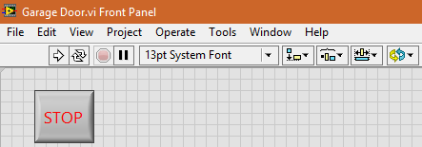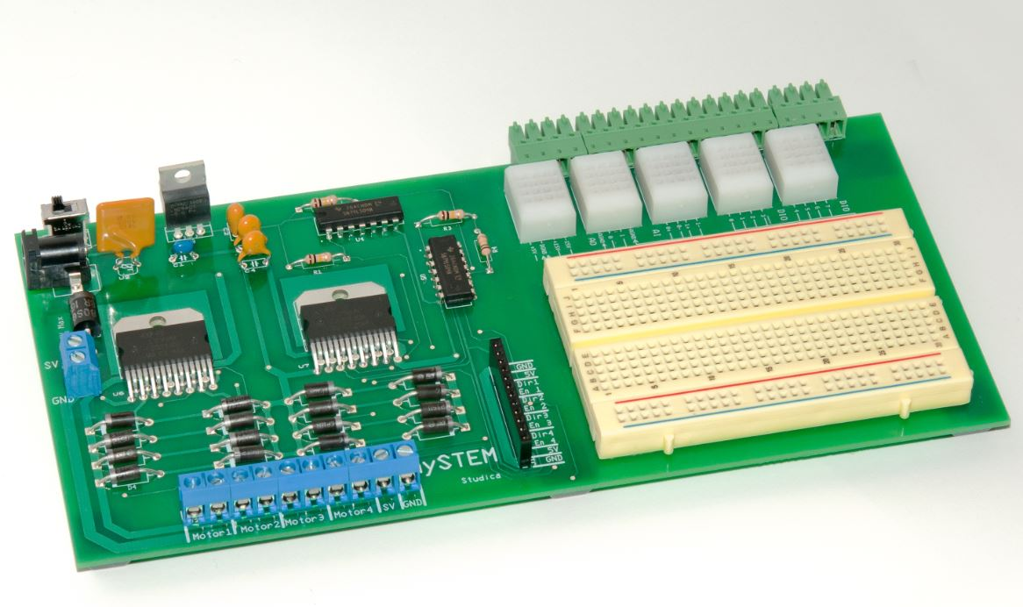

**Press the Stop Button on the front panel after you are done**

**Test your final system before showing it for evaluation. Make sure it works as you would expect. If you find something wrong, refer back to the steps in this tutorial and see if you followed them properly.**

**Make sure it is connected to an external power source**

**Make sure your mySTEM board is turned ON**

**Click the Run button on the toolbar to start the program**